Running the System

Software Prerequisites:

1. MATLAB (preferably a 2014 or 2015 version) with DSP system toolbox
2. All Scarlett 18i8 drivers installed, including ASIO diver
3. Hardware
   1. Connect Focusrite Scarlett 18i8 to the computer
   2. Place each microphone in a stand and place all microphones stands roughly 45 feet away from the computer and 18i8. See (3) in the comments section for more info.
   3. Use XLR cables to connect microphones to the 18i8, as indicated by figure below
   4. Press the two “48V” buttons on the 18i8. The buttons should light up red.
   5. Set the gain knobs all to the same level for each channel. See (1) in comments section.

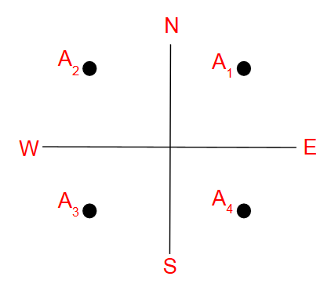

Figure 1: Channel setup

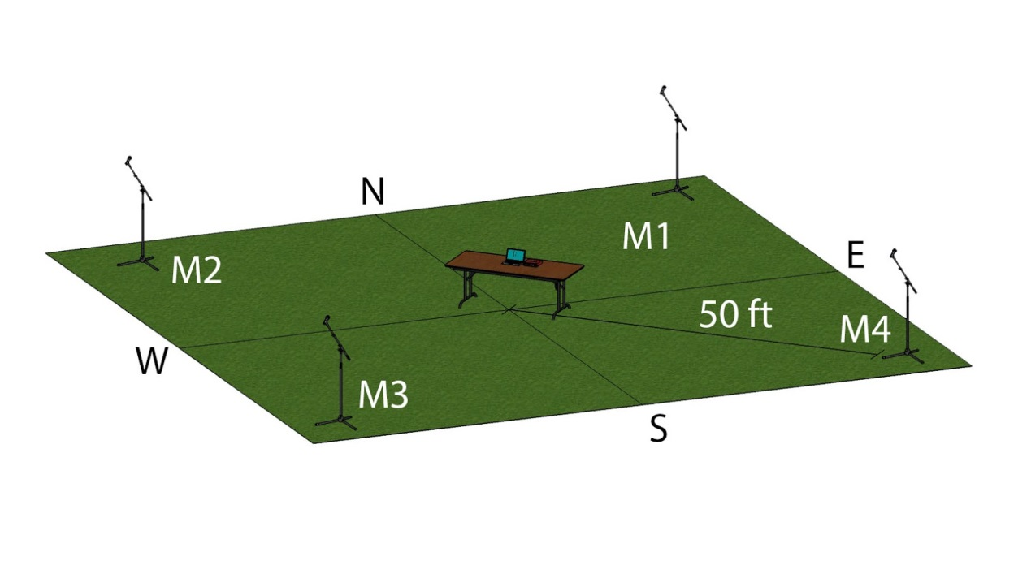

Figure 2: Physical setup of the system

1. Prepare MATLAB
   1. Open MATLAB (we used 2014a/b and 2015b for development).
   2. Add all folders and files that were provided in the drone detection software package to the active path.
   3. Under the “Home” tab, click “Preferences”. In “DSP System Toolbox” settings, select “ASIO” as the audio hardware API.

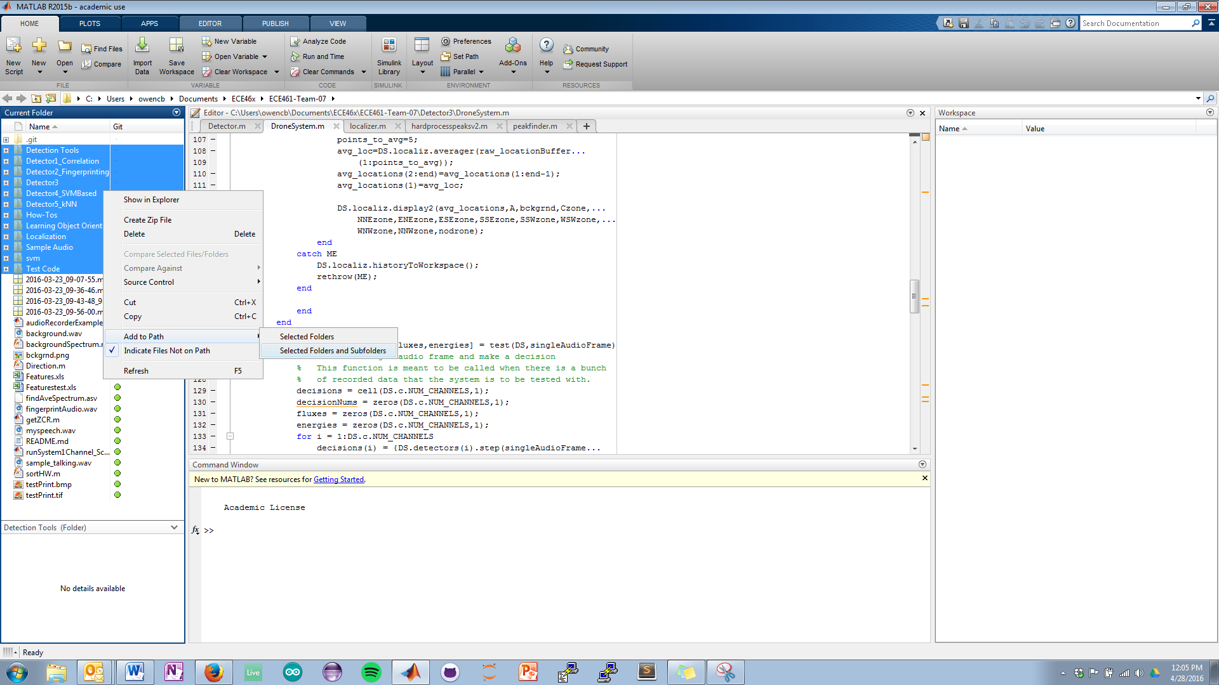

Figure 3: Adding folders to the path

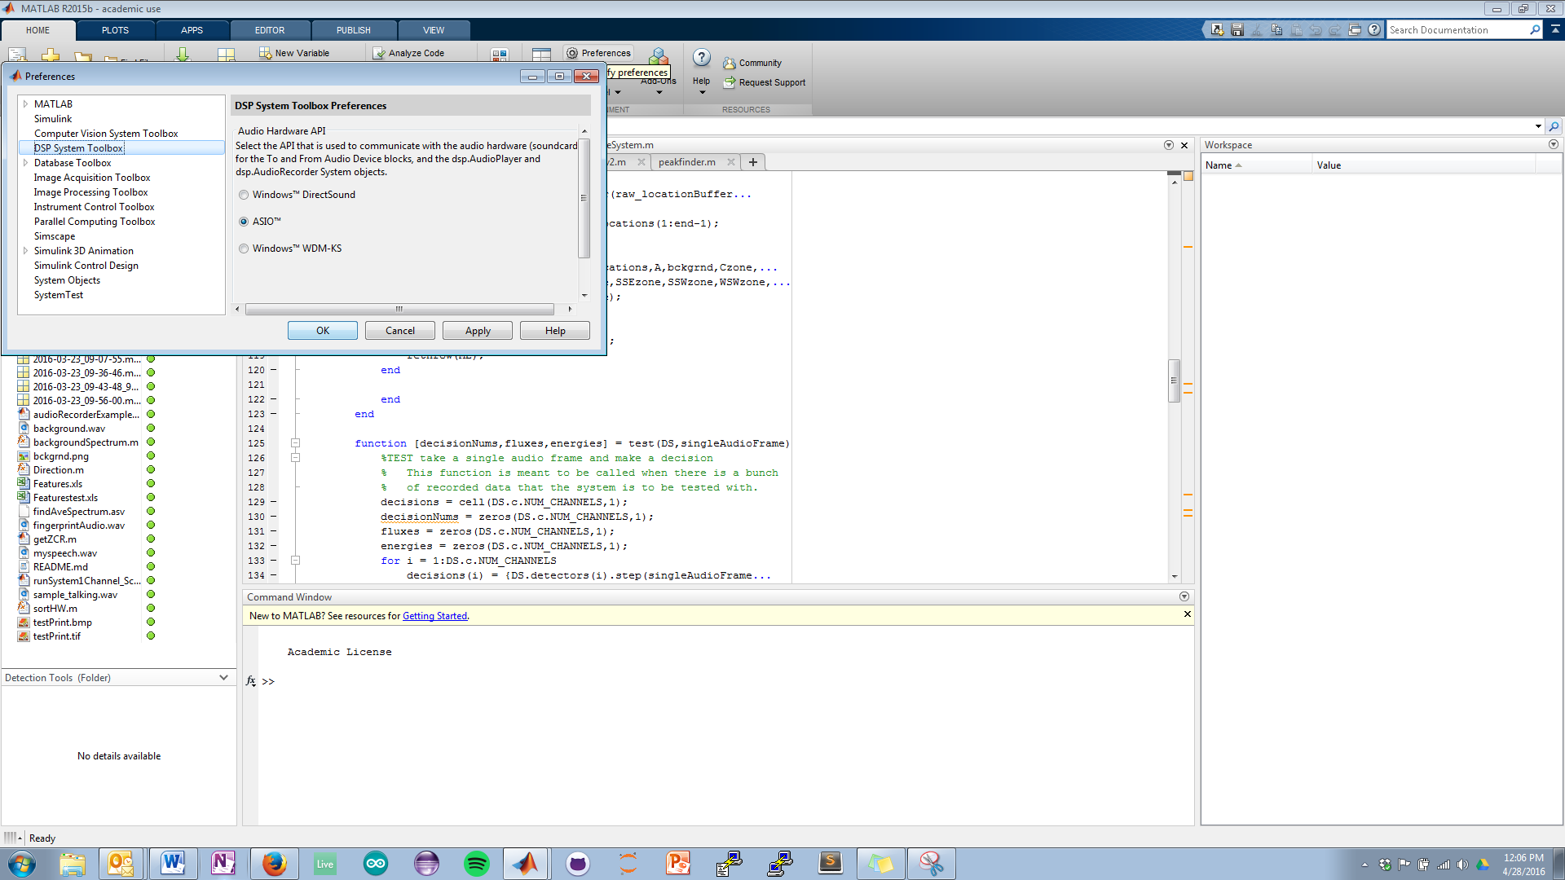

Figure 4: Switching to ASIO drivers

1. Run the system
   1. In the MATLAB command prompt, type runSystem4Channel and press enter.
   2. Similarly, runSystem2Channel can be used to test the system’s functionality without having all of the mics setup. The localizer will not run (because audio is only taken on two channels). Having some ASIO driver installed is required for this to run. See (2) in comments section for ASIO info.

Comments:

1. Gain knobs
   1. The default level that we used was half: the grooves on the knobs pointed straight up.
   2. On days with little wind, the gain can be higher to improve range. High winds will cause clipping, which would be a problem.
   3. Be sure that the knobs are all at the same level; the localization module assumes this.
2. ASIO4ALL
   1. A free and trusted ASIO driver can be found here: <http://www.asio4all.com/>
3. The system depicted in figure 2 shows the microphones 50 feet away from the center of the system. Since the cables are exactly 50 feet and some slack is needed, the stands will be about 42-45 feet away.